05 | Database Design
  - MongoDB logical schema, relationships, constraints and retention
Version 1.0 | 29 October 2026 | Status: Proposed / Pre-development

Model strategy
MongoDB collections use ObjectId primary keys. Foreign-key-like ObjectId references are enforced by application validation, ownership checks and selective indexes; MongoDB itself does not automatically enforce relational foreign keys.

Entity relationship diagram
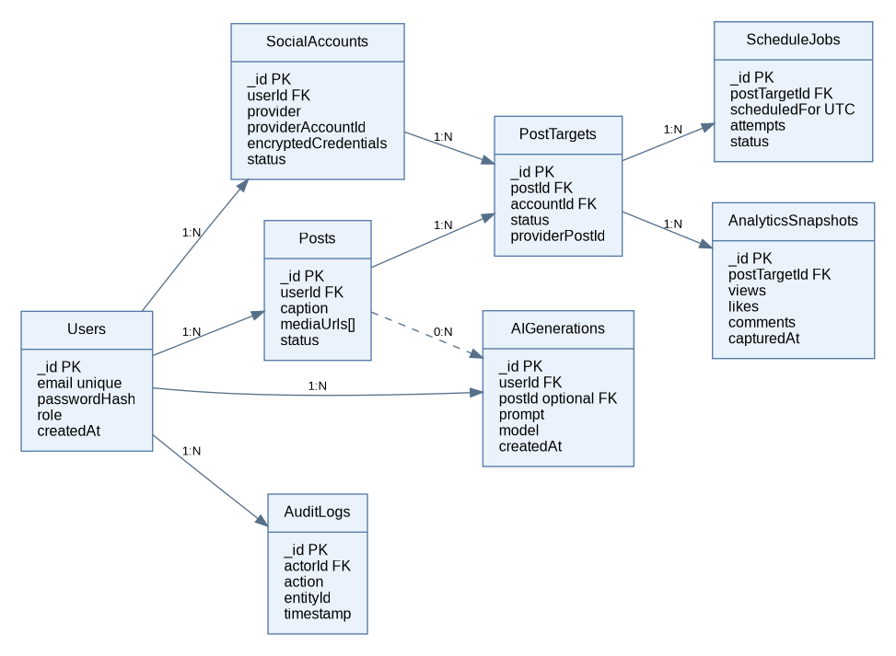

users
Field | Type | Constraint / meaning
_id | ObjectId | Required, PK
name | String | Required, trimmed
email | String | Unique normalized email
passwordHash | String | Required; never return
role | String | creator/admin; default creator
createdAt / updatedAt | Date | Automatic timestamps

socialAccounts
Field | Type | Constraint / meaning
_id | ObjectId | PK
userId | ObjectId | Indexed owner
provider | String | Supported provider/platform
providerAccountId | String | Provider identity
displayName | String | Display-only profile
encryptedCredentials | Object | Protected server-side field
status | String | connected/expired/disconnected
createdAt / updatedAt | Date | Timestamps

posts
Field | Type | Constraint / meaning
_id | ObjectId | PK
userId | ObjectId | Indexed owner
caption | String | Editable required on schedule
hashtags | String[] | Optional
mediaUrls | String[] | Validated asset URLs
status | String | draft/ready/scheduled/...
createdAt / updatedAt | Date | Timestamps

postTargets
Field | Type | Constraint / meaning
_id | ObjectId | PK
postId | ObjectId | Parent post
accountId | ObjectId | Authorized destination
status | String | pending/published/failed/...
providerPostId | String | Optional provider id
publishedAt | Date | Optional UTC instant

scheduleJobs
Field | Type | Constraint / meaning
_id | ObjectId | PK
postTargetId | ObjectId | Related target
scheduledFor | Date | Required UTC instant
status | String | queued/running/retry_wait/...
attempts | Number | Default 0
nextAttemptAt | Date | Optional
idempotencyKey | String | Unique
lastError | String | Sanitized short message

aiGenerations
Field | Type | Constraint / meaning
_id | ObjectId | PK
userId | ObjectId | Owner
postId | ObjectId | Optional linked draft
prompt | String | Sanitized user input
tone | String | Optional
model | String | AI model identifier
generatedText | String | Suggestion output
createdAt | Date | Timestamp

analyticsSnapshots
Field | Type | Constraint / meaning
_id | ObjectId | PK
postTargetId | ObjectId | Related target
views / likes / comments | Number | Nullable; provider dependent
capturedAt | Date | Snapshot timestamp
source | String | Provider origin

auditLogs
Field | Type | Constraint / meaning
_id | ObjectId | PK
actorId | ObjectId | Initiating user
action | String | Canonical action name
entityType / entityId | String / ObjectId | Affected record
timestamp | Date | UTC
metadata | Object | Nonsecret details

Indexes and consistency
- users.email: unique index (normalized lowercase).
- socialAccounts: unique compound index (userId, provider, providerAccountId).
- posts: compound (userId, createdAt descending); optional status filter index.
- postTargets: unique compound (postId, accountId); verify both belong to same owner.
- scheduleJobs: unique idempotencyKey; compound (status, nextAttemptAt) for due claims.
- aiGenerations: (userId, createdAt descending); analyticsSnapshots: (postTargetId, capturedAt descending).
- Use atomic compare-and-set for worker claims; a lease expiry allows recovery after worker crash.

Example MongoDB record (post)
{ "_id": "ObjectId(...)”, "userId": "ObjectId(...)”, "caption": "Launching our student project!", "hashtags": ["#MERN", "#AI"], "mediaUrls": [], "status": "draft", "createdAt": "2026-10-29T10:00:00Z" }

Data integrity and privacy
Every query for user-owned records must apply userId or join through an ownership-validated parent. Token material should be encrypted with a managed secret; revoke/delete on disconnect. AI prompts and analytics should have a documented retention policy; avoid personal data in provider requests.

Reference
Reference: GreatStack, “Build an AI Powered Social Media Automation Platform Using MERN Stack | AI Project Tutorial,” published 28 May 2026, https://www.youtube.com/watch?v=L3OmeClSiQ0&t=348s. The public description was used; this package does not claim frame-by-frame verification or reproduce the video source code.

